Name: | _SOLUTIONS |  |  |  |  | Date: ___________
 | Year 8  Investigation 4, 2013  Topic –Venn Diagrams  In class component |  |  |  |  | 22  = %
Total Time: | 40 minutes
Reading Time: | 5 minutes
Working Time: | 45 minutes
Weighting: | 5 % of the year.
Equipment: | Scientific Calculator  You can bring your copy of your take home investigation
Date out: |  | Week ____ Date _____________ |  | Date Due: | Week ____ Date _____________
Take home component weighting: |  | 0% of the year |  | In-class component weighting: | 5% of the year.
AIM: In this assessment, you will be investigating Venn Diagrams

1. | [6 marks: 1,1, 1, 1, 2]
On the following Venn diagrams about Cats and Dogs shade the appropriate area

- The people who like dogs  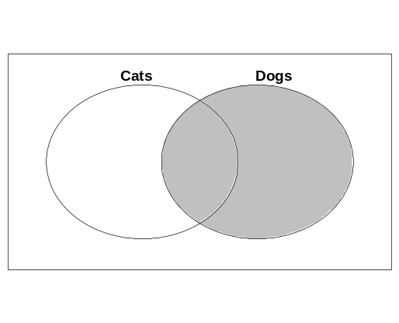✓ | - The people who don’t like cats or dogs  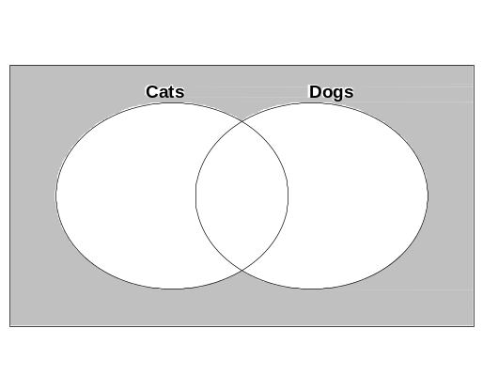✓
- The people who only like cats.  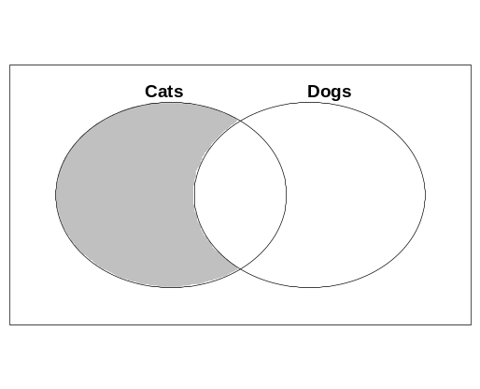✓ | - The people who like both cats and dogs  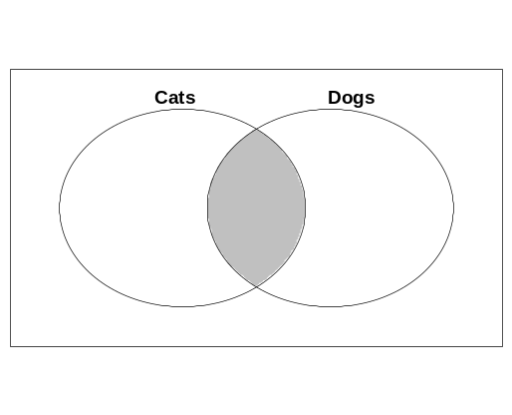✓
- The people who don’t like dogs
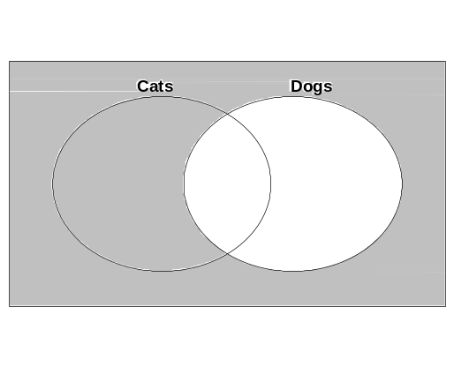✓✓

2. | [7 marks:1, 1,1, 1, 1, 2]
A group of people were surveyed about whether they liked Vegemite or Peanut Butter or both.
The information was placed in the Venn Diagram below.
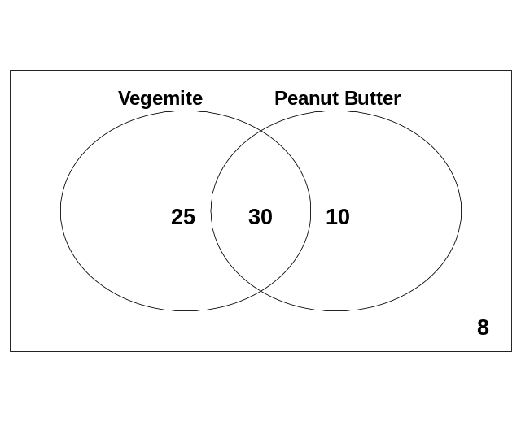
Answer the following questions based on the information in the above Venn diagram

- How many people were surveyed?_73 ✓

- How many people like Vegemite? 55 ✓

- How many people like only Vegemite? 25 ✓

- How many people like Peanut Butter and Vegemite? 30 ✓

- How many people like neither of the options? 8 ✓

- How many people like Peanut Butter but do not like Vegemite? 10 ✓ ✓

3. | [9 marks: 4, 2,3]
A group of people were surveyed about whether they Maths, English or both.

There are 57 people all together
38 like Maths
12 like English
15 like neither

- Place the values in Venn Diagram below which represents this information.(4 marks)
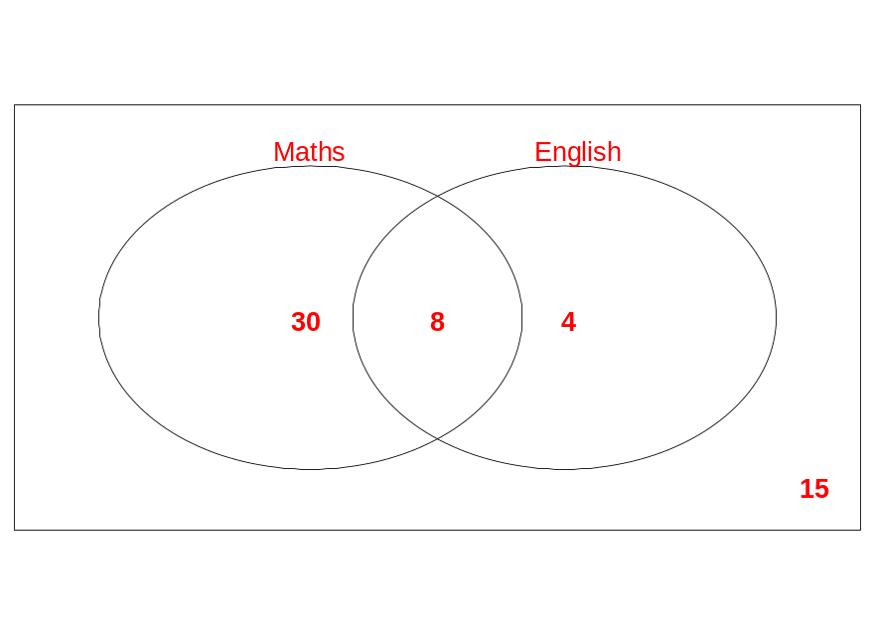✓✓✓✓ 1 each correct number

- Question How many students liked both? 8 (2 marks)

- Explain how you worked your answer to part b) out.
Answers will vary
Read diagram ✓ only 1 marks
Added up Maths and English got 50 ✓ worked out here should be only 42 so 8 were double counted ✓
So there is 8 in the middle✓

(3 marks)

